For immediate release
17 December 2013
POD Tents Launch World First Modular Camping Experience
The world’s first modular camping experience, exclusively designed and engineered in the UK, breaks cover this week with the launch of POD interconnecting tents. As British as a Sunday Roast, the POD adds a fun new twist to the iconic summer staple, with two sizes to choose from, a refreshingly simple build process and pocket friendly pricing.
Totally innovative and created to transform the traditional camping experience, POD is a range of beautifully original tents that are built to be connected together. A social camping experience, users can POD their space with interconnecting tents to build a bespoke accommodation layout on the fly.
By reimagining the concept of form and function, POD has solved a number of common issues with the traditional tent. Perfect for those who want to express their individuality, the POD is the antithesis of standard tents with the two sizes, POD Maxi and POD Mini able to be connected in a multitude of ways. There are no complicated set up instructions to wrestle with making pitching quick and easy and inhabitants do not need to crouch and stoop. Designed to be enjoyed, the POD Maxi and POD Mini unite seamlessly to give endless community opportunities.
Jason Thorpe director of designers M2C Innovation said, “We believe the POD is the first truly versatile social camping tent experience. It is the tent reinterpreted for a new generation. As much social experience as a way of enjoying the great outdoors, the fun of POD is that each unit can be joined together with any other, in any way, to build whatever the user wants. We wanted to put the fun back into camping and with this groundbreaking range, we think we have achieved this. We have worked hard to refine the design and construction of POD, incorporating features such as twin windows, higher wall vents and increased ventilation from user trials to create a 2014 collection that is second to none. Whether you’re off to a festival in a field or foreign shores, POD is an essential companion for friends and families who want to holiday together and have the option of privacy.”
In addition to its external adaptability, the POD Maxi is also internally flexible with an interior that can be created, adjusted and personally designed on demand. An eight man tent, it can sleep eight people spaciously in an open plan sleeping area or, be configured to sleep four with personal sleeping cells and communal living space.
The POD Mini is a smaller four person tent, sleeping inhabitants comfortably with or without private sleeping cells.
To find out more, see the range and view POD videos, visit http://www.podtents.com

About POD
The new, revolutionary POD designed by M2C Innovation is different. POD is a social camping concept that enables tents to be interlinked in order to build a community. Perfect for a growing family, each family can have their own sleeping POD resulting in undisturbed sleep and meaning that you don’t need to buy a larger tent as your family expands – just add another POD. With interconnection tunnels you can safely party into the night with friends whilst staying close to your loved ones – the best of both worlds! A modular design means that you can have a central POD for living in the day and separate internal or external sleeping PODs. Whether you are a welly wearing festival goer, a hardened British camper or enjoy camping further afield POD is the perfect companion.

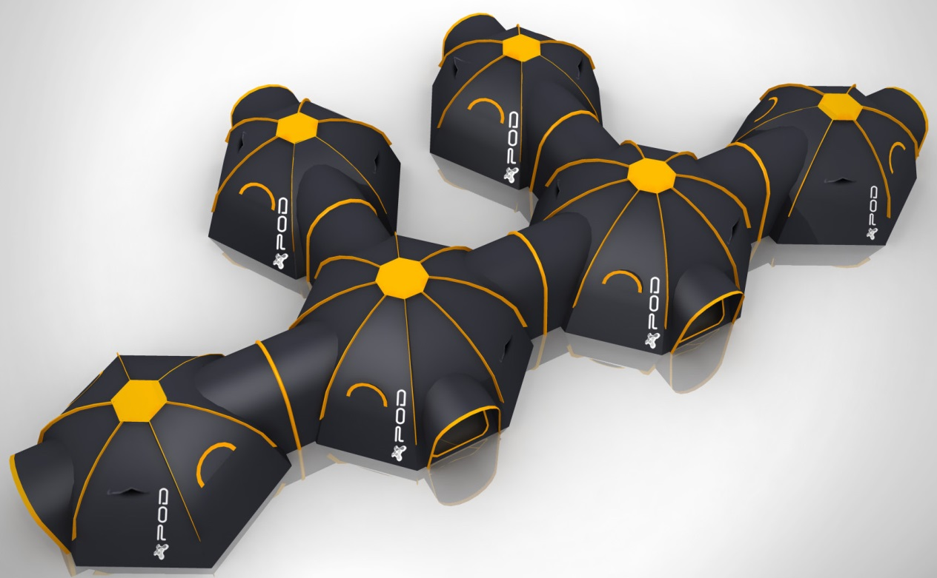

Contact
Issued by M2C Innovation Ltd . Please direct press queries to Jason Thorpe . Email sales@podtents.com or Tel: 01480 869000.
##ENDS##

